WORLD NEWS

APRIL 28, 2015 / 5:30 AM

Last day in Saigon: Iconic UPI photo heralded end of Vietnam War
By
Andrew V. Pestano

WASHINGTON, April 28 (UPI) -- It was April 29, 1975, the last day of the Vietnam War, and people were desperate to get out of Saigon.
UPI photographer Hubert Van Es captured what became an iconic image of the fall of the city: a line of people trying to board a helicopter atop a building.
Van Es died in 2009. But in a recollection of the event for The New York Times in 2005, he told the story of the photo - and why most people are mistaken about what it shows.
About 11 a.m. that day, the evacuation of the foreign press corps began. Van Es, along with UPI Bureau Chief Alan Dawson and reporter Paul Vogle, decided to stay longer. About 2:30 p.m., Van Es was the only photographer in the office when he was alerted that a helicopter had landed on the roof of a nearby apartment building where the U.S. Central Intelligence Agency station chief and some officers lived.
RELATEDUPI Archives: More on the fall of Saigon
"I grabbed my camera and the longest lens left in the office - it was only 300 millimeters, but it would have to do - and dashed to the balcony," he wrote in the Times piece. "Looking at the Pittman Apartments, I could see 20 or 30 people on the roof, climbing the ladder to an Air America Huey helicopter. At the top of the ladder stood an American in civilian clothes, pulling people up and shoving them inside."
It took off with only about a dozen people inside.
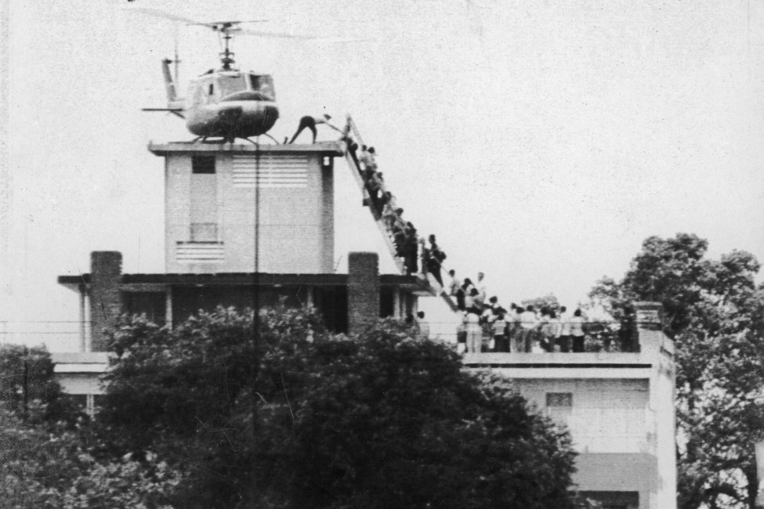
19750429
Van Es rushed to transmit the photo, which in those days was done via radio signal.
RELATEDUPI Archives: The light flickers out in Vietnam
Somewhere in the editing process, an erroneous caption was attached, stating that the helicopter in the photo was atop the U.S. Embassy roof, since that had been the main evacuation site -- and the scene of much panic and chaos as North Vietnamese troops were closing in.
Dan Southerland, who had landed in Vietnam as a rookie reporter for UPI before moving on to the Christian Science Monitor, recalled watching South Vietnamese civilians pressing to get through the embassy gates to safety.
In a recent interview with UPI, Southerland said he assumed many of the South Vietnamese people he knew would be mistreated under the new regime. So he spent his last days in Saigon attempting to arrange for several people to get onto military airplanes or helicopters.
RELATEDUPI Archives: News highlights from 1975
"Fortunately, I was able to get several Vietnamese out, but I was unable to persuade my old interpreter to leave," said Southerland, who is now an executive editor with Radio Free Asia. "He was convinced that the Communists would do him no harm because he was relatively poor. He was wrong. He was interrogated and beaten up and finally had to flee a few years later by boat."
Ken Englade was a UPI field reporter from the Saigon bureau who worked seven days a week for three weeks at a time in the northern part of South Vietnam. Late on the 29th, he, too, was at the embassy gates.
"We had a staff meeting... to decide who wanted to try to make it off the embassy roof and who wanted to stay," he said in a recent interview.
He, Vogle and and UPI staffer Bert Okuley decided to evacuate.
"When we got to the embassy, there was a large but subdued crowd in front of the gate," Englade said. "We had to force our way through. Vietnamese were forcing slips of papers into our hands with their names in the belief that someone inside would recognize them and come to their rescue. It didn't happen."
"I also had to fend off several women who tried to give their babies," Englade said. Englade, Okuley and Vogle were about halfway through the crowd when Vogle, tears streaming down his face, said, "'I can't do it. These are my people.'"
Vogle turned around and walked back.
Meanwhile, UPI audio editor Tom Foty, who now anchors radio newscasts for CBS News, was in New York City, taking Dawson's final radio spots and putting them on the network for subscribers: "I was on duty when the North Vietnamese troops marched into Saigon."
CBS TV aired those reports in its nightly broadcast anchored by the legendary journalist Walter Cronkite, who had also begun his career at UPI.
Dawson, who fought in the Vietnam War as a soldier left the Army to join UPI in 1970. He became UPI's bureau chief for Vietnam and Indochina in 1973. He stayed on after the war until he was expelled by the new Communist government the following September.

